Special frameworks for single page appliation
Angular, react, vue.js

Angular – introduce from google
react – from facebook

Angular js – first one
Angular - second one

google drive, gamil all are run on the angular framework

attributes and properties – in angular
properties and status – in react

There are some differences in naming convesnsion.
Angular (Attributes) = React (Properties)
Angular (Properties) = React (State)

These 3 can be used any of server side packages

Annotations (OOP) = Decorators (TS)
Elements = Attributes

----------------------------------------------------------------------------------------------

module has also a provider
as well as every component has provider

Interpolation Binding Syntax
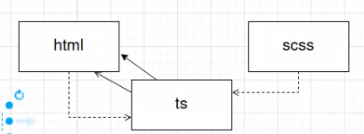

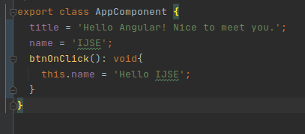

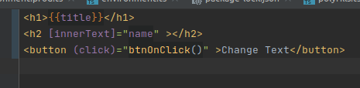

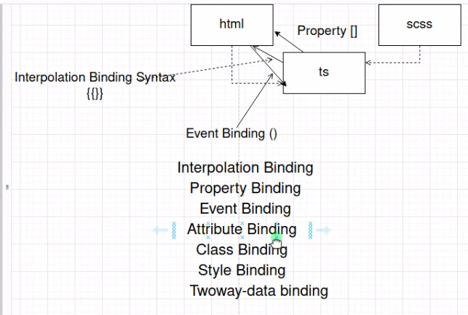

Ctrl+Alt+Shift+L → solve errors in intellij

Directives

There are few types of directives in Angular

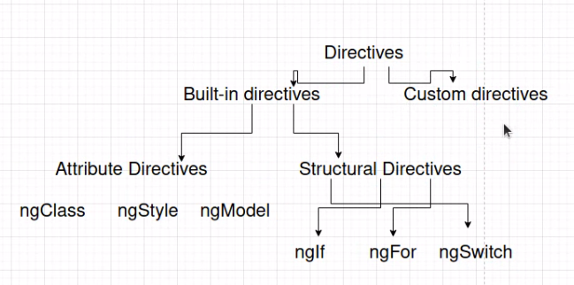
structural directives - do something to Html structure

https://github.com/sura-boy-playground/todo-app.git

==================================================================
Definite Assignment Assertion Operator
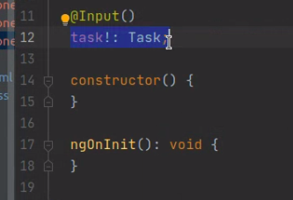

union types using null

